Emily Waterston
2132 Golden Ave
Clovis, CA 93611
ewaterston@mail.fresnostate.com
(559) 797-6375

Experience

Assistant Manager March 2013- Aug 2013
-Maurice’s
- Assisted in opening a new store.
- Logged daily revenue and associate stats.
- Receive, Stock, and Merchandised clothing.
- Supervised five employees.
- Responsible for opening/closing store
- Build daily deposit.
- Provide excellent, up to date, fashionable service to our guest.
Cage Cashier October 2007 – June 2012
-Table Mountain Casino (Friant, Ca)
- Responsible for large quantity bank in Casino Cage.
- Excellent interpersonal and customer service skills.
- Provide monetary instruments for casino floor personnel.
- Verify exchanges from cashiers to and from main bank.
- Reconcile bank and paperwork per
Promoted to Main Bank Relief for 4 years.
- Responsible for logging all bank totals throughout the casino.
- Prepare revenue summary statement from previous day.
- Prepare casino deposit for the following day.
- Fill in as a supervisor when needed.
Head Bartender October 2006- May 2007
-Fiddle Creek Steakhouse (Stephenville, TX)
- Tend/wait bar and tables in restaurant.
- Provide daily inventory log.
- Train staff.
Gottschalks, Sales Associate September 2001-June 2004
-Sierra Vista Gottschalks (Clovis, CA)
- Cashier in Accessory Department
- Well trained in customer service
- Inventory and merchandising

Cashier
Certificate
Functional Movement screen level one certified
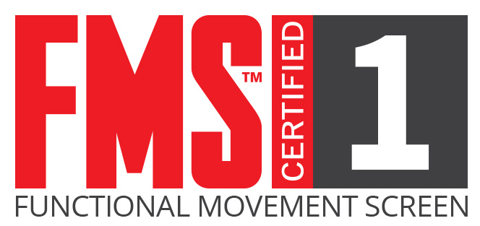
General Education
Buchanan High School- diploma 2004
Willow International Center- May 2017
AA degree Kinesiology-Magna cum laude
California State University-Fresno
BS- Kinesiology, Exercise Science

References
Laura Brinkan- Maurice’s, Assistant Manager- (559) 302-7910 *2 year.
Kelly Luscher - Table Mountain Casino (559)706-2847 *5 years.
Peggy Snider - Table Mountain Casino (559) 907-2389 *5 years.

